How to Save up to 80% on Your Lighting Costs

Seems a bit bold, doesn’t it? But did you know that LED lighting technology has progressed rapidly in the last few years that this number is now achievable?

In fact, LED lights use up to 80% less wattage and last up to 50,000 hours (42 times traditional lighting).

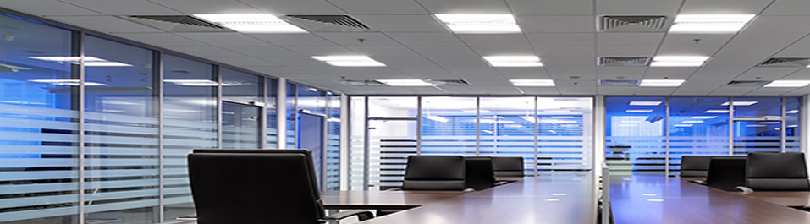

**Utility Rebates**

Not only that but utility rebate programs like those sponsored by ComEd, Ameren or Focus on Energy (Wisconsin) bring the costs of investing in LED even lower. These programs can run out annual budget so it is important get in early!

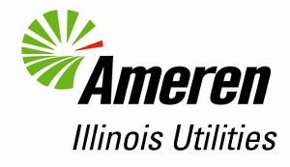

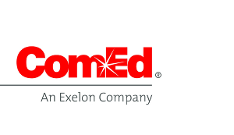

**Main Benefits**

Here are some of the benefits your organization can enjoy with LED:

* Return on Investment (ROI)
  + The ROI on LED lighting can be very high, over 50% annually sometimes. Try getting that in the real estate or the stock market. In many cases, financing is also available to cover 100% of the costs. Here’s an example:
* Form & Function
  + LED lights can come in a diverse range of colors and nearly any lighting arrangement can replicated with LED lights. And because LED is semiconductor-based, you can seamlessly control it through software and mobile apps (saving you more!)
* Environmentally-friendly
  + No mercury is produced, 90% less C02 is emitted, and less waste is produced by not having to purchase bulbs so many times.

**Get a Lighting Audit**

Here at EnergyBillQuote.org, we’re committed to helping businesses in the Midwest and nationwide in reduce their energy bill costs. We have partnered with several LED lighting companies that are generously offering FREE Lighting Audits – no strings attached. They do all the work, find the appropriate utility rebates and tell you how much you can save. Curious to see which one is a good fit in your area?

<button>See My Results</button>